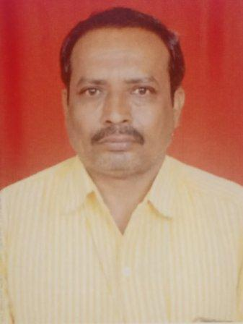
NAME: Rathwa Chandrsinhbhai Kadvabhai
AT: Thana Falia, Devgadh Baria, Dahod
MO NO: 9428512751
EMAIL ID: chandrasinh.rathwa@anandi-india.org
SELF REFLECTION-
I believe that learning and leadership qualities are my greatest possession. Ability to deal with people, the ability to grasp things fast and willingness to work has always been my strengths.
EDUCATION QUALIFICATION:
NO | Qualification | Institute/University | YEAR | Percentage
1 | S.S.C | G.H.S.E.B | 1992 | 65.62%
2 | Agriculture Deploma | University | 1994 | 66.62%
3 | H.S.C | G.H.S.E.B | 1996 | 67.62%
4 | BRS | Nutan Gram Vidhyapith | 1999 | 70.62%

AREA OF INTEREST:
- Sustainable Livelihood, Women farmers land rights, and Organic Farming practices.
- Strengthening Women collectives
- Water harvesting and Watershed Management
- Tribal Welfare.
- Children and Women.
- Youth and Education.

- Work Experience
- Asst. Project coordinator in ANANDI ( Area Networking and development initiatives) 2006 to Present.
- Planning, Monitoring and evaluation of LAK and Livelihood program.
- Mentoring and regular Input to Community resource persons and Sangthan Members.
- Community mobilization and intervention at village level for collective action.
- Capacity building of CRP’s, elected panchayat members, Youths and Community members on different issues such as Government schemes and services, various acts, Applications and portals such as My Ration, Gram Samvaad, Ipds portal, NSAP etc.
- Facilitating training, Workshops and meetings with women farmers on organic farming, management of seed bank and cost cutting & improving income.
- Design and lead campaigns such as RRLJ, MGNAREGA, etc.
- C.m.t trike hal shheraa balok na 10 gam ma

- Comunity organiser at Paryavaraniya Vikas kendra, Rajkot 2003 to 2006.
- Worked closely with salt pan workers mainly, womens in Malia miyana to improve their living standard. formed womens saving groups/collectives, trained them on financial literacy, guided them in availing loan from banks & setting up small/micro businesses.
- Formed water shed committees, facilitiated capacity building training of this committee and through this committee initiated water harvesting work.
- Connected Shrimp farmers to bank for financial support like loan to buy tools and techniques needed in the process of Shrimp fishing / farming, helped them in building their network with other institutions and organisation.
- Maaliya miyana vistar na mitha maa kam krta aagriya sathe temni septi ane aarogy,pivana paani ane rheva mate mkano ni suvidha mate na avrnesh krva na kam no anubhv che,

